General Bidding Bulletin
Please refer to the monthly updated bulletin for details specific to the current bid period.

block/Reserve tool to help determine if a waive is necessary
https://pbswaivetool.com/

If you expect to be out of the country or on layovers during bidding, we suggest placing a default bid beforehand.

Internet Connection
PBS requires a strong and consistent internet connection during the synchronization and submission processes. Public and/or hotel WiFi is not ideal as it may limit the speed or quantity of information that can be downloaded. PBS must be able to download all of your relevant personal information including the pairings for your base and classification into your browser during the synchronization process. If the internet connection is weak or spotty this process may not properly complete or take a very long time. Even if you have a top-of-the-line internet connection, if other household members are using it at the same time to livestream, online game or any other online activities which require a lot of bandwidth (ex: bitcoin farming), you may still experience problems. Internet access is government controlled in certain countries.

It is possible that you cannot connect to PBS from some countries. Consider bidding before/after a layover rather than while on layover in these countries.
Known internet restrictions have been reported in China (including HKG), Chile, Cuba, Egypt, Europe, South America and Qatar. There have also been reported access issues in Israel, Asia, Korea and Thailand.

REMINDER – Minimum Credit bidders -
When the number of Minimum Credit bidders is limited, the most senior crew members will not be affected by the limit. Everyone junior to the limit who used Set Condition Minimum Credit will have “Maximum Min Credit Bidders Reached” displayed below their Set Condition Minimum Credit bid line in their Reasons Report. Once the limit for minimum credit bidders is reached, PBS can no longer honour the request for Minimum Credit for anyone affected by the limit.

If PBS cannot honor a request for Minimum Credit, it will continue to read your bid and award you pairings as if the Minimum Credit request was not made, so long as you do NOT have Clear Schedule Start Next Bid Group in the same bid group.

If PBS cannot honor a request for Minimum Credit and you are using BOTH Set Condition Minimum Credit AND the Clear Schedule and Start Next Bid Group instruction in the same bid group, PBS will honor the CSSNBG instruction and jump to the next bid group.

LANGUAGES
If you have a language, please cover yourself with your route language in your bid. We always suggest requesting your prefer offs as PBS does attempt to award you prefer off(s) requests unless you are required for date, date/language or language credit.

If you are considering bidding reserve or prefer off else start next bid group (or clear schedule and start next bid group)-please cover yourself with another start pairing bid as if you are required for your language PBS can deny you your reserve request.

REMINDERS OF PAIRINGS DEPARTING AFTER MIDNIGHT
PBS logic for Depart On remains attached to the first flight departure and not the pairing check-in time. For example, T5004, the Depart On is attached to March 29th even though the pairing check-in is on the 28th. March 29th is also the date you see reflected in the small calendar when you expand the pairing and also the date circled in the horizontal list of dates.

PBS does take the check-in date into consideration when calculating the total number of days in a pairing (Pairing Length). If a pairing checks-in on the calendar day prior to the first day of departure, it is taken into account. T5004/March displays 05 Days in the pairing length blue bubble.

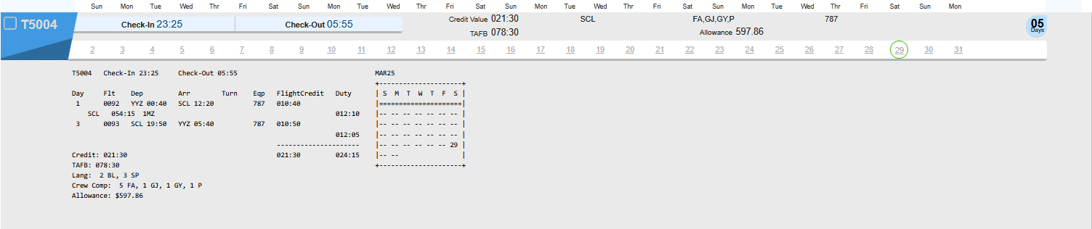

CAUTION:
If you have entered a CURRENT bid before bids open July 16 this bid is NOT submitted even if you have selected the icon submit button. Only the default and training bids can be submitted prior to bids opening. Please ensure that your bid is submitted.

REMINDER
Award results may be found under:
Crew Scheduling & Planning and select eforms
Please Confirm your schedule via EFORMS and NOT Globe
Schedules in other systems (Globe) are not official until published to Netline

This is a reminder that your PBS reps are here to guide you with your bids, your final submission is your responsibility, any errors made within your bid are incumbent upon you and not the PBS team members who do their best to assist you.
Please email us at the new PBS email pbsyyz@local4092.ca

As with any update to PBS, you should:
Clear your browser’s cache and web data

23-1 Supported Browsers/Devices/Operating System (OS) - Minimum Requirements
Mobile Devices
NAVBLUE N-PBS is supported and tested on the following mobile devices, using either Safari or Chrome applications:
- iPad
- iPad Air
- iPad Pro
- iPhone Plus (version 8 or higher)
- iPhone Pro (version 8 or higher)

Operating Systems
The N-PBS Bidder Interfaces are tested and supported on the following operating systems:
- iOS 15.0
- Windows 10
- Catalina

Supported Browsers
NAVBLUE N-PBS is supported and tested only on the most recent versions of the following browsers:
- Chrome
- MS Edge
- Firefox
- Safari (on Macintosh computers running macOS Catalina)

Browser Settings

NAVBLUE N-PBS requires javascript, pop-up windows and cookies enabled in all browsers.

information on using Web App on the Aeronet portal under Crew Scheduling & Planning > Bidding Tools & Information > Bulletins.
Also, YVR PBS has many videos for viewing. Google search www.local 4094 and select PBS and then PBS videos
PBS Videos

Only your last SUBMITTED bids are used for the award process.
When you SAVE your bid, a copy of your bids (Current, Default & Training) is only stored on the device that you are using at the time. You do not get a confirmation number when you save your bids. If, for example, you save your bids on your laptop (without submitting) and then go to your iPad, you will not see the changes to your bid that were made on your laptop.
Submit save

NOTICE:
We will make every effort to answer your email on the day that it is received.
However, due to a large increase in the volume of email that we receive during the bid period, any email received after 8pm EST may not be answered until the following day.

To assist us in responding to your questions, please email us from a personal email address and include the following information:

Your full name
Employee number
Phone number where you can be reached. Sometimes it can be more efficient to call you.

If you have a question about time off and legalities (1/7 and 4/14) please provide a copy of your current month's schedule as the blocking rules apply from month to month.

Pairing Revisions
Schedule revisions may include the cancellation of pairings between bid open and close. As such, Cabin Personnel are encouraged to ensure they bid sufficiently to protect themselves.

REMINDER:
There are three types of coverage (unstacked) award:

A Tripstack: where you are required for a specific date (or time). PBS searched for bid lines that allow it to “satisfy” or assign pairings on the time/date. PBS will attempt to honour Avoid and/or Prefer Off bid lines where possible, however they may be ignored when no options exist.

Language Tripstack: similar to the Tripstack however, a specific language requirement is needed on a specific date.

Language Credit: where the date (or time) is not crucial, only that you operate as much credit as possible for your language. PBS will read all of your bid lines however; the only pairings assigned in this process are those requiring the language.

Tripstack is the most common type of coverage and usually occurs when most bidders prefer to have time off such as weekends and or civic/religious holidays. The information below is specific to Date coverage (Tripstack) however, some of the processes are similar to Language coverage (Language Tripstack).

What is a “Stack”?
“Stack” is a term used for pairings that share a given date. These pairings do not need to depart that date; rather the date may be at the start, middle or end of the pairing. We generally look at pairings as the time that we check-in to the time that we check-out, PBS also takes into account crew rest as part of the pairing.

Why does Coverage occur?
Coverage is meant to ensure that pairings are crewed. While we would all like weekends off as well as holidays that is not possible. With a “Line Bidding” style of blocking, where bidders bid on an entire block vs. pairings, coverage is built into the pre-set blocks.

DATE COVERAGE VS LANGUAGE COVERERAGE
It is possible for PBS to award separate Coverage pairings to crew members for date alone and for date with language. These two types of Coverage Awards are not necessarily connected, and it is possible for date Coverage to occur before language Coverage and vice versa. For example, PBS will force Coverage awards on a date because it knows it has a shortage of available crew members to cover the flying on that date. At the time it is awarded flying to cover this date there may not be a shortage of language speakers in the base which need to be assigned pairings. Later in the process, the system may then identify a shortage of language speakers available and from this point on, language Coverage Awards may begin. Therefore, it is possible for a language qualified F/A to be forced on a Coverage Award on a date by virtue of their seniority and then subsequently a more junior F/A may be forced on a Coverage Award for their language. When PBS must assign Coverage awards either for date alone or date and language, it will read your bid looking for the first possible bidline that allows it to award you a pairing that meets the Coverage requirements. If none is found, it will go into the Embedded AWARD PAIRINGS bidline and find a pairing. Once Coverage assignments are awarded, the remainder of the block is built around the Coverage awards. KEEP IN MIND THESE PAIRINGS ARE ENTERED ON YOUR BLOCK FIRST.

REMINDER
It is recommended to take a screenshot or a print out of your final bid. For a bid to have been submitted, there should be a confirmation number: example below
Confirmation #: 1246973054 Last Submitted: 2021-11-10 16:07:21 UTC

REMINDER OF CHANGES IN LOGGING IN USING THE DIRECT LINK
- Enter Direct access link in browser
- Redirected to Microsoft Login
- Enter your AC email
- Redirected to Portal login but auto populated with your AC email instead of using your employee number (AC000000)
- Enter regular portal password
- MFA authentication request sent to your phone or key chain dongle (depends on how you set up MFA)
- Approve on your phone or enter dongle code
- Redirected to Navblue to enter your Offline Key (only with New UI)
- Synchronizing
- PBS opens on Info page

You're also invited to view the new UI introduction video
Introduction to the New UI (11:32):
https://www.youtube.com/watch?v=Lm6x1lVWpug
Other helpful videos are provided by YVR PBS
they are under the Local 4094 website, local4094.ca
under the PBS > PBS Videos tab

If you are using the New UI
Supported Browsers & Devices (21-1):.
iPad Air / iOS 13.3.1 / Mobile Safari
iPad Pro / iOS 13.3.1 / Mobile Safari
iPad Mini 2 and newer/ iOS 12.4.5 / Mobile Safari
iPhone Plus sizes and equivalent / iOS 13.3 / Mobile Safari
Surface Pro 3 / Windows 10 Pro / Chrome 83x
PC / Windows 7 Pro, Windows 10 / IE 11, Chrome 83x, Firefox 76.x, Microsoft Edge 81.x
Mac Computers / MacOS Sierra 10.12.6 / Safari

NEW CHANGES WHEN BOOKING BACK ON AFTER AN ILLNESS
If you exceed 7 days, you will need a medical note. Basically, effective on the 8th day at midnight, you are ineligible for a block award without a note.

737 aircraft
If you do not want to fly on the 737 – you will have to request avoid pairings if any aircraft type 737.
Please note, you can still be awarded a pairing with a DH on a 737 aircraft. You would have to avoid the pairings that have a deadhead on a 737.

Submit or Save
Remember that you can Submit your bid as many times as you would like prior to bid close. It is highly recommended that you Submit your bid after entering every couple of bid lines so that you do not lose any data. If you have the GREEN dot in the upper right corner of your bid page then that means that you are connected to WIFI and you should submit using the SUBMIT tab. The SAVE tab should only be used if you do not have access to WIFI.

Did you know?
Any flight that is more than 8 hours in length, crew can request crew bunk kits (depending on aircraft type if crew bunks are available). If you have further questions, please contact the crew rest committee.
Chair /
Président
Robert Hatfield
crewrest@accomponent.ca
Michelle Duhaney
Local 4092
michelled@local4092.ca

Reserve Information and a link to open time bidding tutorial
Reserve Duty and Reassignment Please note the following Call-In times
• Call-In Reserve: 20:00-23:00 (local time)
• Reassignment: 19:00-21:00 (local time

https://youtu.be/NfESwUXRe6w

- You may Pre Select pairings on the first day of each of your Days ON or OFF
- Open Pairings for the next block month will become available 2 days prior to the end of the previous block month and awarded the following day (the day prior to the start of the block month)
- New Pairings (if there are any) will become available for bidding at 10 am every day
- Reserve VE, Voluntary Extension may only be achieved after you have completed all of your Reserve days ON. If you have the last days of the block month off and they are NOT GDOs, you may apply for VE pairings on these final days off
- Credit for any pairings worked PRIOR to all of your Reserve Days ON being completed, will be applied to your 75 hours
- Credit for any pairings that you work AFTER all of your Reserve days ON have been completed will be ON TOP of your 75 hours (this is Reserve Voluntary Extension/VE)
- If you work a VE Pairing that overlaps into the next block month and you are awarded Reserve in the second month, the overlapping credit will be applied to your 75 hours MMG

REMINDER
Position GJ is forward galley (business class)
Position GY is aft galley on all widebody aircraft

If one is not specific on a bid line example: award pairing if layover LHR. PBS will attempt to award FA first, followed by GJ and finally GY

One can avoid a position or award a position

Bidding Tip Reminder
PBS does not see next months’ block. PBS sees only one month at a time. This means if you have vacation in July over 76:00 and you wish not to fly, it is recommended to request off the last day of the block month i.e., June in this example, otherwise you can be awarded an overlap pairing that may bring you over 80:00 hours. If you have questions, please email pbsyyz@local4092.ca

REMINDER when checking your award

Award results may be found under Crew Scheduling & Planning and select eforms
Other systems, like Globe, may only be updated after the Publish to Netline date.

If you want to be on Reserve only, please remember to activate your reserve bid
Below is an example and lines on how to do this
Links on New UI and Old UI
20.2 Bidding Reserve ONLY https://youtu.be/QDrpLgvK1O8
20.2 Old UI Bidding Reserve ONLY https://youtu.be/BPWBSW1anhI

1. Award Reserve
-------------------------
Pairing Bid Group
Award Pairings
-------------------------
Award Reserve
-------------------------
2. Reserve Bid Group
3. Prefer off Aug 3, 2026

REMINDER

We have noted that crew are not activating their reserve bid when they use the Clear Schedule and Start next bid group or Else Start next bid group. Below are links on how to do this

- 20.2 CSSNBG to Reserve https://youtu.be/qvtLyldTHuI
- 20.3 ESNBG to Reserve https://youtu.be/Z9JPEVVE5yI

Duty Summary Chart and PBS update
Please see attached documents
Language from the Collective Agreement
L60.04.05 The designation of a pairing (B14, LOU 18, LOU22A and LOU 22B) shall be based on the duration of the longest leg within that pairing.
L60.04.06 An additional thirty (30) minutes of on board crew rest will be applied to LOU 18, LOU 22A and LOU 22B flights.

This Letter of Understanding applies to long rang flying and will be split in two parts:

Part A will describe a duty period which contains a single flight leg and is scheduled between 16:16 and 18:00 hours;
Part B will describe a duty period which contains a single flight leg and is scheduled between 18:01 and 19:30 hours.
The parties agree that there are four (4) separate extensions of the duty period limitation: Article B14; LOU 18; LOU 22, Part A; LOU 22, Part B;

Ferry Flight
At the employee's Home Base only, the duty period will commence thirty (30) minutes prior to the actual departure time of the ferry flights. There is no post duty period applied for ferry flights.

**Note** when using the NEW UI and activating AWARD RESERVE do not select MAX ABOVE and/or add any number to MAX above unless you only want to be on reserve if you are a certain number. If you have any questions, please email us at pbsyyz@local4092.com or send us a screenshot of your bid and we can verify if you activated your reserve bid correctly.

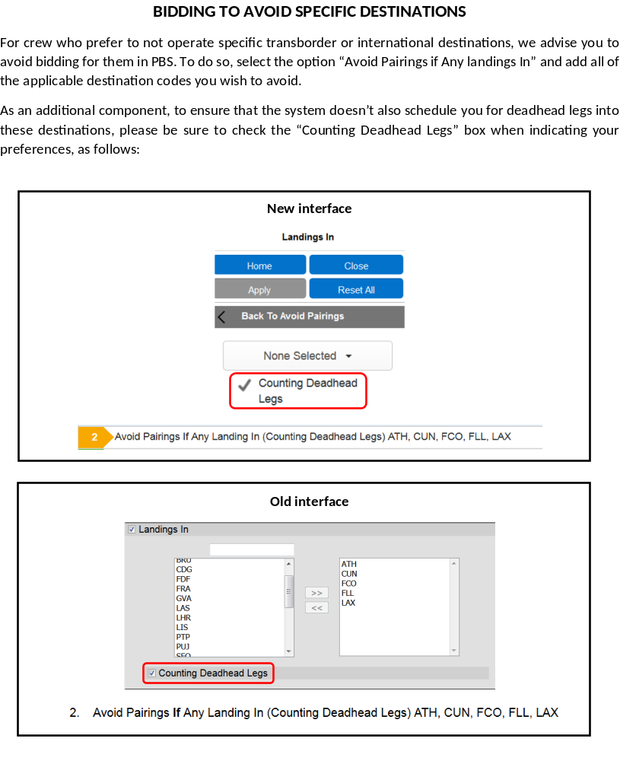

Pairings are revised every month before bid closes and the pairing revisions are published in Aeronet under In Flight Services >Crew Scheduling and Planning>Block Bid Packages. If you bid by pairing numbers, it is recommended that you verify the pairing revisions before bid closes.
The block times can be adjusted at any time by the commercial team due to a number of things such as slot availability route performance or equipment on route

Forget and Redo
If you are awarded for coverage, PBS will follow your bid and read and follow Forget & Redo instructions during the coverage award process. If you use a Forget that brings pairings previously avoided back into the pairings pool, then they are available to be awarded after the Forget bid line. That may be a bidding strategy where “If I have to work on X and Y then I want this type of flying.” If that is not your preference and you would rather that PBS return back to a higher point in your bid and reprocess higher bid lines, then a Redo From should be considered.

Time off after or before during coverage
PBS will not use bid lines that have “Time Off Before” and/or “Time Off After”. The rational behind this is that PBS can not put itself in a situation where to honour a Time Off Before/After prevents additional coverage dates from being processed.

Followed By:

- The entire Followed By bid line will not be used during coverage awards

Set Condition
Set Condition Minimum Credit is not considered for Coverage Awards. Coverage awards are processed first and to the extent required. The Set Condition Minimum Credit request is considered once PBS has completed Coverage awards and reads your bid to complete your block

REMINDERS

If using the comm center computers, ensure that you are completely logged out.

if you use your default to bid, please ensure your current bid does not have a number one beside start pairings. Current bid is a higher priority over default. PBS would award you here
<< Current Bid >>
-------------------------
1. Pairing Bid Group (this is activated PBS would award you here)
Award Pairings

Waiving
If one waives the 4/14 rule this means one does not need 4 days off in a 14-day period
If one waives the 1/7 rule this means one can work up to 10 days
On a block one can waive both rules but on reserve one can only waive one rule and the other must be honored. YOUR history (previous month) is considered
PBS reads time off left to right.
Prefer off weekends can not be forgotten

Coverage pairings are for either date/date language/language credit/date and time and are awarded first. If you do not have a legal block with coverage pairings, PBS at this point will continue to read your bid.

Print out your final bid
It is advised to Always print out your final bid or have a screenshot of your final bid. Please ensure the confirmation number is visible.

FOLLOWED BY AND POSITIONS
order of positions was is seen by PBS when followed by was used.
The automatic left-to-right position ordering does not apply within followed-by bids.
Given this functionality, if a bidder wants a position preference within a followed-by bid, they would need to enter multiple copies of the followed-by bid, with different positions (for each section of the bid) in whatever order they want, for example:
- Award Pairings If A If Position GJ Followed By Pairings If B If Position GJ
- Award Pairings If A If Position GJ Followed By Pairings If B If Position FA
- Award Pairings If A If Position FA Followed By Pairings If B If Position GJ
- Award Pairings If A If Position FA Followed By Pairings If B If Position FA

COUNTING DEADHEADS:
With the "Avoid Landings In" bid line, there is an add-on for Counting Deadhead Legs. If this is not checked then PBS will not avoid pairings that deadhead into the station. This add-on is in both the new and old ui.
Example below: if one does not select the option of counting deadheads. One can still be awarded a pairing landing in these destinations, if there is a deadhead in that station.
Avoid Pairings If Any Landing In YEG, YFC, YHZ, YLW, YOW, YQB, YQM, YQR, YQT, YUL, YVR, YWG, YXE, YXY, YYC, YYT
Your pairing should read: Avoid Pairings If Any Landing In (counting deadhead legs) YEG, YFC, YHZ, YLW, YOW, YQB, YQM, YQR, YQT, YUL, YVR, YWG, YXE, YXY, YYC, YYT

Cover yourself
If you are not certain you can hold a block, please cover yourself with a reserve bid. Ensure that you also request time off on your reserve bid.
If you are qualified in more than one language (HI/PJ, AR/BL, MD/CA etc) cover yourself in the languages you are qualified in. Certain months one language may be required over another.

PLEASE REMOVE GP FROM YOUR BID
Any default bids with "GP" will not be converted. Any member with GP in their default bid will need to replace it with GJ. IF you have a GP on your bid, your bid will enter denial mode. GP does not exist so PBS reads it as Avoid If Position ____ which essentially avoids EVERY position.

Requesting pairings on the first day of the block month
Requesting a pairing departing on the first day of the block month but the check-in is the day prior, PBS considers previous month's history for this type of pairing. If you have a GDO on the last day of the previous block month you can be denied this pairing as you are on legal crew rest and the check-in would be before your crew rest ends. Block holders are assigned their GDOs by the system only Reserve can you request GDOs depending on your bid.

REMEMBER ON PAIRINGS THAT HAVE A DEPARTURE AFTER MIDNIGHT THE CHECK-IN IS THE DAY BEFORE

below is an example of a pairing departing on the Oct 29th at 00:55. But remember the check-in will be on the 28th of Oct.
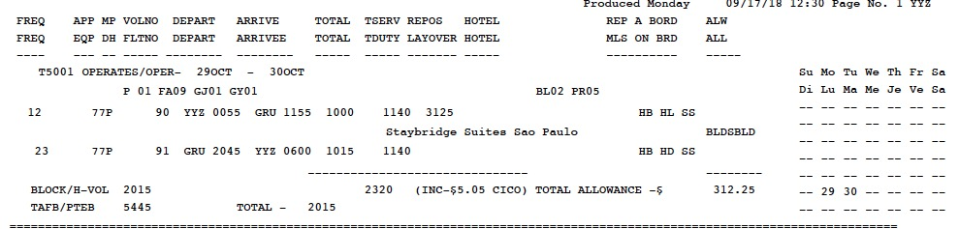

1) PBS pairing searches displays the pairing by the CHECK-IN TIME.
2) The Bid Package displays pairings as the DEPARTURE TIME.
3) Scheduling treats the pairings by the departure date of the first flight regardless of the check-in time/date.

DEADHEAD LEGS

Do not use D/H legs < 0. PBS will not find any pairings to match this bid (when a pairing has zero D/H legs, it is not “LESS THAN ZERO) rendering the entire bid line useless.

Award Pairings bid examples with deadhead legs:

Award Pairings If Deadhead Legs = 0 legs
• Awards pairings with no deadhead legs.

Award Pairings If Deadhead Legs > 1 legs
•Awards pairings with two or more deadhead legs.

Award Pairings If Deadhead Legs Between 1 legs And 2 legs
• Awards pairings with one or two deadhead leg

Avoid Pairings bid example:
Avoid Pairings If Deadhead Legs > 1 legs
• Filters (removes) all pairings from the pairing pool with more than one deadhead leg.

Avoid Pairings bid example:
Avoid Pairings If Landings In BOS, JFK • Filters (removes) all pairings from the pairing pool if any operating legs land in either BOS or JFK. You cannot avoid landings in your home base.

USING IF NOT IN A BID LINE
If Not may be confusing. Be sure to fully understand the functioning of “If Not” if you choose to use this criterion.
EXAMPLE: Award Pairings If Not Any Layover in LHR And Of Duration > 030:00
PBS can still award you a layover in LHR as long as it is as the layover less than 30 hours

Do NOT use Award Pairings If Position FA or GJ on its own.
Award Pairings If Position FA on its own will allow PBS to assign ANY pairing as long as it is an F/A position.
Award Pairings If Position GJ on its own will allow PBS to assign ANY pairing as long as it is an GJ position.

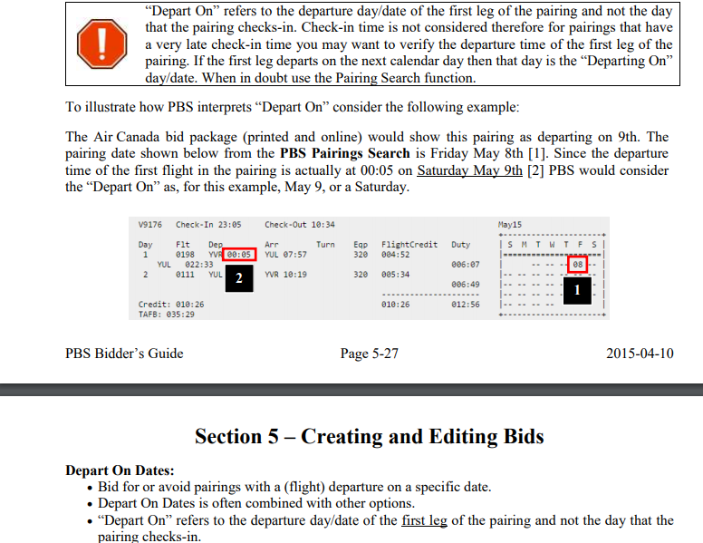

ERROR when bidding layover Stations.
There has been an increase of FAs mixing up the Departing ON parameter with the Layover ON parameter when using the new UI. Please note, when selecting ON in the Layover option this is when the layover will start and not when the pairing will depart.
Here are two examples:

Award Pairings If Any Layover In MAD And On Oct 20, 2018 - this bid line reads to have the Layover in MAD starting on the 20th and therefore one would be departing on the 19th

Award Pairings if departing on Oct 20, 2018 if Any Layover Mad – this bid line reads to depart on Oct 20th and have a layover in MAD.

If you have any questions, please see a bidding instructor.

Image is from the New UI – Layover
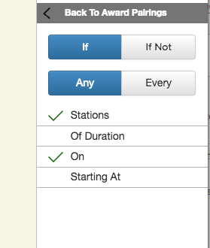

Set Condition minimum day off vs Set Condition Consecutive days off
Set Condition Minimum Days Off: Tells PBS to build your block with a minimum number of days off in a row (will not go below that number of days off anywhere in the block). Condition bid lines are placed at the top of your bid, may not be forgotten and may be denied if necessary. Condition bid lines may cause PBS to ignore or deny lower bid lines in order to honour the condition.

Set Condition Consecutive days off: The main purpose of Set Condition Consecutive Days Off is to allow you to request a set number of consecutive days off in the block month or within a specific range of dates. Set Condition Consecutive Days Off bid line(s) will be placed at the top of your bid since PBS must use it as it awards you your block. All of the consecutive days off must fall within a specified Range Of Dates or if no range is specified, the block month is used as the range. Dates outside the block month will not be considered or used as part of the consecutive day off period.

ACTIVATING RESERVE
Many crew members do not activate their reserve bid – when using else start next, clear schedule and start next bid group (and wanting the next bid group to be reserve) please ensure it is activated.
Example below:
1. Pairing Bid Group
2. Waive 4 Days Off in 14
3. Waive 1 Day Off in 7
4. prefer off Aug 3, 2026 else start next bid group
Award Pairings
-------------------------
5. Award Reserve - activated reserve bid
-------------------------
Pairings Bid Group
Award Pairings
-------------------------
Award Reserve
-------------------------
6. Reserve Bid Group
7. Set Condition Maximum 6 GDOs
8. Prefer off Aug 3, 2026

Any questions, please see a bidding instructor

RESERVE BIDDING -ELSE START NEXT BID GROUP AND GDOs
When assigning GDOs, PBS does read how you requested prefer off except when using the Else Start Next bid group
Example:
Set condition maximum GDOs 2
Prefer off June 24,25,26,17,18,19,3,4 else start next bid group

If PBS could award you these days off, your GDOs would be June 3,4. With the ESNBG GDOs are assigned left to right and not the order they are requested.

RESERVE – ALL OR NOTHING AND MAXIMUM GDOs

All or Nothing forces PBS to honour “all” which includes the assignment of days off as well as the assignment of GDOs. If for example, one requests 13 days off were and has requested these days off in the All or Nothing bid line PBS will also need to assign all of them (13) as GDOs. As the maximum number of GDOs possible is 11 there was no way for PBS to honour the GDO assignment.
it is recommended to have the line with all or nothing matching the requested GDO.

ROUTE LANGUAGES
If you have a route language, please cover yourself with your route language in your bid. We always suggest requesting your prefer offs as PBS does attempt to award you prefer off(s) requests unless you are required for date, date/language or language credit.

If you are considering bidding reserve or prefer off else start next bid group (or clear schedule and start next bid group)-please cover yourself with another start pairing bid as if you are required for your language PBS can deny you your reserve request. Below is an example:
1 Pairing Bid Group
2. Waive 1 Day Off in 7
3. Set Condition Minimum Credit
4. Prefer Off Aug 3, 2026 else start next bid group
5. Award Pairings If Any Layover In AMS, CDG, CPH, DEL, DEN, DUB, DXB, EWR, EZE, FCO, FRA, GRU,
Award Pairings
-------------------------
6. Award Reserve
-------------------------
7. Pairing Bid Group
8. Waive 1 Day Off in 7
9. Set Condition Minimum Credit
10. Prefer Off Weekends Minimum 1
11. Prefer Off Aug 3, 2026
12. Award Pairings If Any Layover In AMS, CDG, CPH, DEL, DEN, DUB, DXB, EWR, EZE, FCO, FRA, GRU, HKG, HND, IAH, ICN, KEF, LAX, LGA, LHR, MAD, MUC, MXP, NRT, ORD, PDX, PEK, PVG, SCL, SEA, SFO, SNN, WAW, YHZ, YUL, YVR, YYT, ZRH And Of Duration > 024:00
13. Award Pairings If Allowance Amount > $200 If Every Duty Legs < 3 legs If Any Layover Of Duration > 016:00 If Pairing Check-In Time > 10:00 If Pairing Length Between 2 days And 3 days
Award Pairings
-------------------------
Pairing Bid Group
Award Pairings
-------------------------
Award Reserve
-------------------------
14. Reserve Bid Group
15. Set Condition Maximum 2GDOs
16. Prefer Off Aug 3, 2026
-Please speak with an instructor if you have any questions.
-Junior BL speakers are also encouraged to cover themselves like the example above.

PBS FLASH BULLETIN – PASSWORDS IN PBS
Should you encounter a password error when attempting to log into PBS, first check to be sure that you are entering the correct employee number and password. If this does not work, then we suggest that you reset your ACaéronet password making sure not to include any of these special characters:
& < > " \ ' : * ;
Please note that the system may allow you to reset your ACaéronet password using one of these characters, but the subsequent log in to PBS will not recognize them. Keeping your ACaéronet password strictly alpha numeric should solve your issue.

Returning to work with a Medical Note
Under Article B4.05.02, cabin crew on Sick Leave that are scheduled to return to work may bid on
and be awarded a block for the month of their return, provided they submit medical evidence to that
effect to Crew Planning.
As a reminder, a medical certificate specifying the anticipated return date must be received prior to
bid close. It may be delivered in person or transmitted by fax to (514) 422-7989 (VIA email is now accepted) and, once sent,
cabin crew are asked to contact Crew Planning to ensure that the certificate was received.
Recently, there has been an increase in invalid medical certificates among those submitted. Please
note that an anticipated return date must be indicated.

For example:
ACCEPTABLE
“... [the patient] will return on Aug XX. “ “...

Unacceptable
[the patient] may bid for Aug 2026. “
[the patient] will be off from XX to XX. “
[the patient] will be absent until XX ... “

Pairings
With the new pairing optimizer please remember that 8000 series can be a full crew, one flight attendant, two flight attendant or purser pairings. Even the 5000 series and 7000 series can be one of these scenarios.
Reminder: with the new pairings many pairings are built with 1SD. Service Directors can not be assigned language if it is a 1SD pairing.

Trip Trade
Crew members will be able to access the system but will be unable to perform any trade for overlap pairings during the PBS award period. After publication of contesting, you will once again be allowed to trade overlap pairings.
Trip Trade Assistance
There are multiple PDF documents outlining the features of the system, with step-by-step instructions and screen shots. To access these documents, log on to ACAeronet > IFS > Crew Scheduling and Planning > Automated Trip Trade System
HELPFUL HINTS
If you are bidding via an I pad, smartphone, MAC or I pod there have been reports of bid lines changing or being deleted. It is highly recommended that one prints out their bid or take a screen shot of their final bid submission. Make sure you can see a confirmation number and the date stamp. If it is possible, please go to a laptop or computer and verify that your bid is inputted correctly.

1. Please verify your PBS calendar for overlap credit, vacation credit, training awards, and if your month has been prorated due to retirement or an absence.
2. Pairings are revised every month before bid closes and the pairing revisions are published in Aeronet under In Flight Services >Crew Scheduling and Planning>Block Bid Packages. If you bid by pairing numbers, it is recommended that you verify the pairing revisions before bid closes.
The block times can be adjusted at any time by the commercial team due to several things such as slot availability route performance or equipment on route.

3. If you hold a route language (i.e. GE, MD, HE, JA, HI, PJ, IT or any other route language), it is recommended to bid pairings that require your language.
4. There have been reports of bidding difficulty when bidding from layover destinations; it is recommended that you have a bid submitted before leaving home base if possible.
5. Always print out your final bid.
6. If you want to use your default bid, ensure there are no bid lines in your current bid. If you see a number 1 in front of Start Pairings in your current bid, this is the bid PBS will use. PBS will award you a block from the embedded award bid line.
7. If you are buddy bidding, it is advised not to use Bid Groups.

Logging into PBS not possible, taking too long:

- Most issues can be resolved by clearing the browsers cache (bidder should search how to clear the cache for their browser)
NOTE: It is suggested that the cache be cleared for “All Time” (e.g. in the case of Chrome). The bidder should be aware that this will remove links, etc.

- In some cases, it is required to perform additional steps to resolve the sign in issue:
  - Clear the cache
  - Close all tabs in the browser
  - Close the browser
  - Repeat the log in process

- With IOS devices using Safari such as iPads/iPhones, we have seen issues resolved by clearing the “History and Web Data” under Settings > Safari

- With IOS devices using Safari such as iPhones/iPads, we have seen issues resolved by first closing “old” sessions of PBS in the Safari app in addition to closing Safari

Offline Key (New Interface Only):

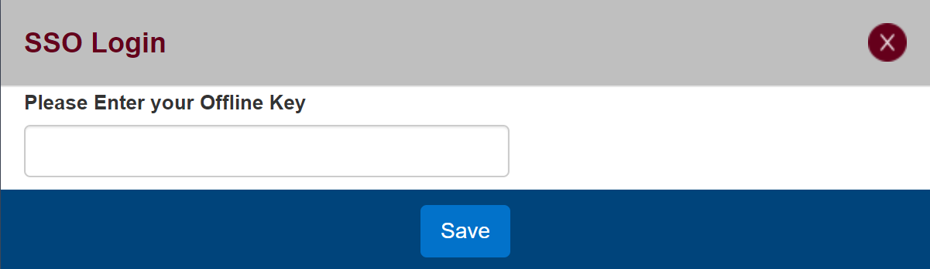

- The Offline Key is a user defined “password” that is used when the bidder accesses the system offline (hence Offline Key)

- The bidder enters their Offline Key and clicks on Save then PBS should start

- The Offline Key can be anything however special characters may cause issues

- The Offline Key is specific to the device and browser that the bidder is using PBS on
  - A bidder may use the same offline key on multiple devices/browsers however this does not mean that their bids are transferred to these different devices/browsers
  - Also, a bidder may use a different offline key on different devices/browsers HOWEVER they must use the specific offline key with the specific device/browser that it was used on

- If the Offline Key entered is different than the one expected the following pop up will appear:

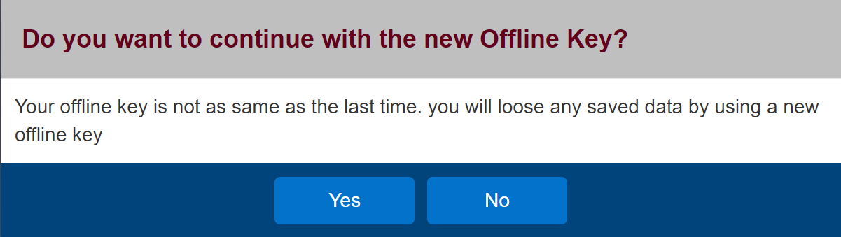

- In this case the bidder may:
  - If they entered the incorrect offline key, click No
    - This will log them out and the Signed Off screen will be displayed. They must then close their browser and start the process over
  - If they do not remember or accessing saved bids is not required, then they may click Yes
    - The “new” offline key will be saved, and PBS should start

Bidding Assist
Please, send us an email at pbsyyz@local4092.ca. If you would like to speak to an instructor, in your email please include a telephone number so we may call you and the best hours to contact you.

Please remember, many pairings may change. The pairings may be showing during bidding/awards but then can be revised and or cancelled once awards are published.

Claudia, Lynda, Lynne and Roger


